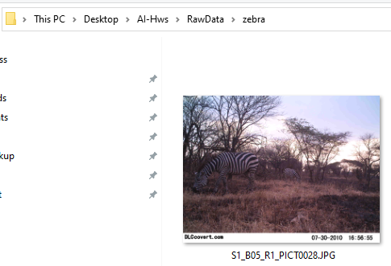

Image contained time stamp which ultimately throws off the accuracy of the multiple classification of classes (zebra, wildebeest, buffalo)

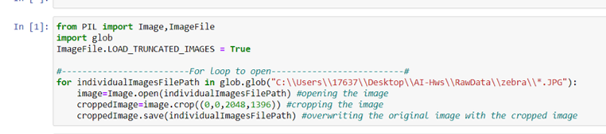

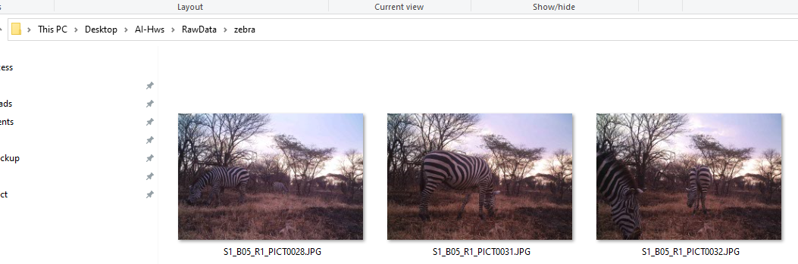

Cropped images no longer contains the time stamp at the bottom